Hong Kong Institute of Vocational Education (Tuen Mun)
Department of Information Technology

Higher Diploma in Software Engineering

Final Year Project (ITP4116M) - Initial Report
(2025/2026)
Find Lost Pets App

Supervisor: | Sky Wong
Co-Supervisor: | Rex Lau
Student: | Xie Tsun Kit  Cheung Man Hei  Kwok Chiu Chit  Leung Ka Hei
We declare that this is a group project and that no part of this submission has been copied from any other student’s work or from any other source except where due acknowledgement is made explicitly in the text, nor has any part been written for us by another person.
Student | Contribution to the project (%)  (Total 100%) | Signature
Xie Tsun Kit | 20% | 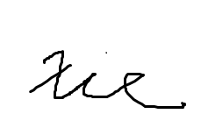
Kwok Chiu Chit | 20%
Cheung Man Hei | 20% | 
Leung Ka Hei | 20%
Chan Yuet Yi | 20%

Abstract

Many lost pets here can’t go back to their owners because people who see them don’t have an easy way to report. They want to help but don’t know how, so important clues are wasted. Our platform fixes this problem. Development of a new app, this report will showcase the architecture design of the newly search pet system.

The objectives of this project are to develop a mobile application that leverages AI-powered image recognition and location-based technologies to assist pet owners in locating their lost pets. This interim report provides an overview of the project's progress in addressing the driving question: "How can Software Engineering techniques be used to develop software systems for supporting human activities?" The report covers the system requirements, problem analysis, detailed design, and a critical evaluation of the project's development so far.

Table of Contents
Introduction-------------------------------------------------------------------------------P.4
driving question--------------------------------------------------------------------------p.5
The requirements -----------------------------------------------------------------------p.6
Documentation for problem analysis -----------------------------------------------p.8
Documentation for detailed design -------------------------------------------------p.22
Implementation --------------------------------------------------------------------------p.33
Results and conclusions --------------------------------------------------------------p.38
Program listing --------------------------------------------------------------------------p.41
installation guide -------------------------------------------------------------------------

Introduction
Finding missing pets is a challenging task in Hong Kong, as pets may have strayed far from where they were last seen. Pet owners typically resort to traditional methods such as posting flyers, posting on social media, and contacting the police, but these methods are time-consuming and do not always yield immediate results.
There has another search pet app. But it cannot be used in Hong Kong, and the situation is different in Hong Kong. Therefore, it is proposed to develop a spectacular, powerful, dependable system for the pet's owner.
Our project is developing apps on android phones. We have successfully integrated AI into our apps. The ai now get the photo in mobile to analyses the breed. The pathways for negotiation in the existing systems are phone calls and WhatsApp.
Current Problems
In Hong Kong, people see pets are family members, yet the city’s unique environment make hard of recovering lost animals. The problem stems from three key factors. First, high-rise buildings, heavy traffic, and dense crowd disorients escape pets. Second, existing recovery systems are not useful in Hong Kong. Current lost pet recovery in Hong Kong is fragmented, relying on manual flyers and social media. This leads to slow, reactive searches and low reunion rates. The official body (AFCD) is overstretched, and there is no real-time search network. Many lost pets remain left in shelters or are never found.
Proposed Solution
This project proposes an Android mobile application that leverages artificial intelligence to streamline lost pet recovery in Hong Kong. The app features three core functions. First, an AI-powered image recognition module that analyzes user-uploaded photos to identify the pet's breed. Second, a database that references lost and found listings using breed and location data. Third, an integrated negotiation system that directs communication between owners and finders through in-app phone calls and WhatsApp. By automating breed analysis and providing familiarity, the app reduces search time, minimizes misidentification, and increases success in the find pet.

driving question
The driving question for this project is: "How can Software Engineering techniques be used to develop software systems for supporting human activities?" The progress made in answering this question can be summarized as follows:
Requirement Gathering and Analysis：
- Conducted user interviews and market research to identify the key requirements and pain points faced by pet owners in locating their lost pets。
- Defined the scope and functionality of the proposed mobile application, including pet photo upload and identification, location tracking, notification system, and community engagement features。

System Architecture and Design：
- Designed the overall system architecture, comprising the mobile application, and backend services.
- Developed use case diagrams, class diagrams, and sequence diagrams to model the system's behavior and interactions.
AI-powered Image Recognition：

- Designed and implemented the pet classification model, incorporating data preprocessing, model training, and real-time inference capabilities.
- Developed the notification system to alert nearby users and coordinate the search and recovery efforts.

The progress made in addressing the driving question demonstrates the application of Software Engineering techniques, including requirements engineering, system design, AI/ML integration, and location-based services, to develop software systems that supports the human activity of locating lost pets.

The requirements
1.Scope
In the system, there are two different types of interfaces. One is for pet owners. Another one is for app users. Pet owner interfaces that will allow users to post, and view pet information. The app user interface is only for taking photos to the ai and replying to normal user's message.
2.Functional Requirements
The lost pet-finding mobile application is designed to provide the following key functionalities:
Pet Photo Upload and Identification:
- Allow users to upload photos of their lost pets
- Utilize AI-powered image recognition to accurately identify the pet's breed, color, and other distinctive features

Notification and Alert System:
- Notify nearby registered users about a lost pet, including details such as the pet's appearance and last known location
- Enable users to report sightings of the lost pet and share updates with the community
Integrated Pet Database:
- Maintain a centralized database of registered pets, their owners, and associated information
- Allow users to search for and access details about lost pets in their vicinity

Community Engagement:
- Facilitate collaboration and crowdsourcing among pet owners to aid in the search and recovery of lost pets
- Provide features for users to share updates, post alerts, and coordinate search efforts within the app's community
3.Non-Functional Requirements
User-friendly Interface:
For a good interface design, clean and easy-to-use menus is needed to let the user use function easily. The users can find the function by category.
Operating 7x24 :
We would like our service to be available at any time. Users can view and post any information at any time they want.

Documentation for problem analysis
Use case description
Actors: Public User, App User (Pet finder, Pet owner)
Use case name: | Login
Use case ID: | UC01
Actor(s): | App User
Brief Description: | Login to the system account
Flow of event: | - User choose the "Login" button  - User Enter email and password  - User clicks the "Login" button  - The system shows page
Postconditions: | - The user is granted access to the application's core features.  - System session is maintained (Automatic login enabled).
Alternative flows and exceptions: | If email or password is incorrect, the system reminds the user.
Non-Behavior requirements: | /
Assumptions | The user has a system account.
Issue: | /
Source: | /

Use case name: | Register
Use case ID: | UC02
Actor(s): | Public User
Brief Description: | The user registers an account with email
Flow of event: | - Select create account  - The system shows the register page  - Enter email and password
Postconditions: | /
Alternative flows and exceptions: | - If email or password is incorrect, the system reminds the user.
Non-Behavior requirements: | /
Assumptions | /
Issue: | /
Source: | /

Use case name: | Upload an unknown pet
Use case ID: | UC03
Actor(s): | App user
Brief Description: | The user finds a pet in street
Flow of event: | - User takes photos to the system  - Give the photo to the AI  - System will store the pet information to database
Postconditions: | /
Alternative flows and exceptions: | If the AI cannot identify the breed, the user manually enters the breed name.
Non-Behavior requirements: | /
Assumptions | /
Issue: | /
Source: | /

Use case name: | Upload lost pet
Use case ID: | UC04
Actor(s): | Pet finder and app users
Brief Description: | The user uploads the image and location
Flow of event: | - User click report lost pet  - User takes photos to the system  - The system answers the information of the pet (e.g. breed).  - Users confirm  - The system will store images, information and location to database.
Postconditions: | /
Alternative flows and exceptions: | If information is incorrect, the user can change it before upload
Non-Behavior requirements: | /
Assumptions | /
Issue: | /
Source: | /

Use case name: | Find lost pet
Use case ID: | UC05
Actor(s): | Pet Owner, Pet finder
Brief Description: | The user finds the pet on this app
Flow of event: | - The owner clicks ‘get cat’ or ‘get dog’ button  - The system will show the pet data  - Pet owners click "Contact notification" button to contact another user
Postconditions: | Pet owner should login first
Alternative flows and exceptions:
Non-Behavior requirements: | /
Assumptions | /
Issue: | /
Source: | /

Use case name: | Upload pet
Use case ID: | UC06
Actor(s): | Pet owner
Brief Description: | The user uploads the image before missing
Flow of event: | - User takes photos to the system  - System will store the pet information
Postconditions: | /
Alternative flows and exceptions: | If a pet is lost, the user can click the ‘I lost it’ button to upload the pet information.
Non-Behavior requirements: | /
Assumptions | /
Issue: | /
Source: | /

Use case name: | Search lost pet
Use case ID: | UC07
Actor(s): | Public user
Brief Description: | The user search latest losing pet
Flow of event: | - The user chooses pet type in home page  - System shows the lost pet
Postconditions: | /
Alternative flows and exceptions: | /
Non-Behavior requirements: | /
Assumptions | /
Issue: | /
Source: | /

Use case name: | analysis pet
Use case ID: | UC08
Actor(s): | App user
Brief Description: | The user analysis pet
Flow of event: | - The user chooses pet photo  - Give it to AI  - AI give back the analysis report
Postconditions: | /
Alternative flows and exceptions: | /
Non-Behavior requirements: | /
Assumptions | /
Issue: | /
Source: | /

Use case name: | Contact pet owner
Use case ID: | UC09
Actor(s): | App user
Brief Description: | The user context pet owner using calls or WhatsApp
Flow of event: | - Select a pet owner  - Click the phone number to go to Whatapp
Postconditions: | /
Alternative flows and exceptions: | use the phone to get a calls
Non-Behavior requirements: | /
Assumptions | /
Issue: | /
Source: | /

Use case name: | Add private Pet info
Use case ID: | UC10
Actor(s): | App user
Brief Description: | Add private Pet information
Flow of event: | 1.Click the account image  2.input info profile  3.save
Postconditions: | /
Alternative flows and exceptions:
Non-Behavior requirements: | /
Assumptions | /
Issue: | /
Source: | /

Use case name: | Logout
Use case ID: | UC11
Actor(s): | App user
Brief Description: | Logout the app
Flow of event: | 1.Click the setting image  2. Click logout
Postconditions: | /
Alternative flows and exceptions:
Non-Behavior requirements: | /
Assumptions | /
Issue: | /
Source: | /

class Diagrams
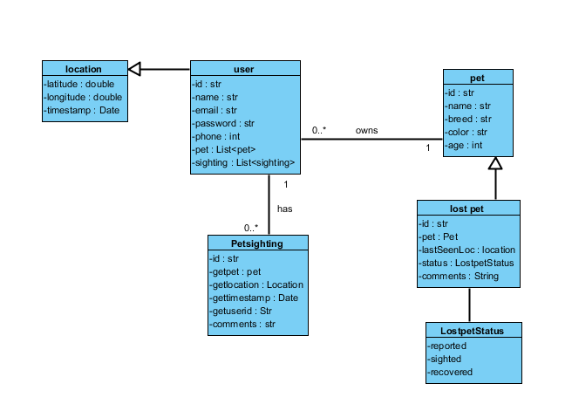

Use case diagrams
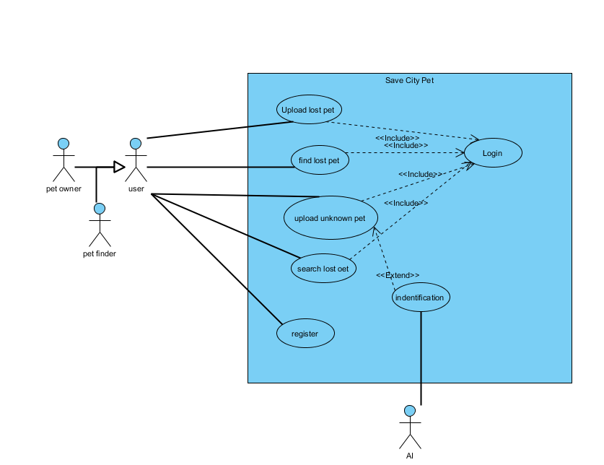

sequence diagram
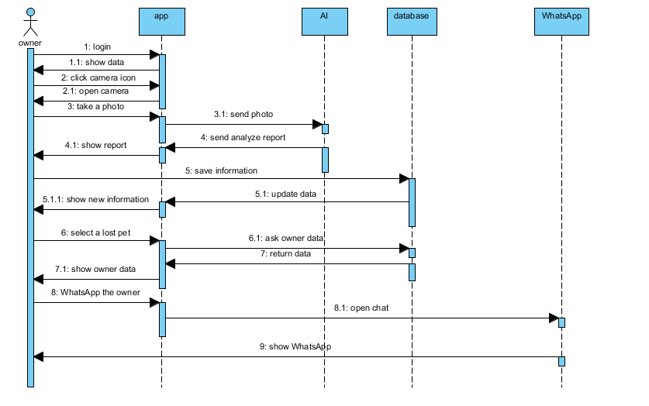

data dictionary
Entity: User
Stores registered user account information
Attribute | Data type | Description | Extra
user_id | int | Unique identifier for each user | primary key,auto increment
phone | varchar (15） | User's mobile number
email | varchar (100） | Optional email address for notifications
user_name | varchar (50） | User's display name

Entity: Pet
Stores information about individual pets
Attribute | Data type | Description | Extra
pet_id | int | Unique identifier for each pet | primary key,auto increment
 | int | User who owns this pet | Foreign key(User.user_id）
 | varchar(50） | pet's given name
breed | varchar(50） | Breed name
age_years | int | age of pet

Entity: LostReport
Stores lost pet submissions
Attribute | Data type | Description | Extra
lost_id | int | Unique identifier for this lost report | primary key,auto increment
 | int | Owner who submitted the report | Foreign key(User.user_id)
 | int | Pet that is lost | Foreign key(Pet.pet_id)
 | varchar (255) | Where the pet lost
age | int | age of pet
Lost_time | datetime | Date pet was last seen
additional | text | Any extra information
report_image | varchar (255) | Main photo of lost pet
created_time | datetime | Report submission time

Entity: FoundReport
Stores found pet submissions
Attribute | Data type | Description | Extra
found_id | int | Unique identifier for this found report | primary key,auto increment
 | int | Owner who submitted the report | Foreign key(User.user_id)
 | int | Pet that is lost | Foreign key(Pet.pet_id)
 | varchar (255) | address of finding location
finder_contact | int | Finder phone number
Lost_time | datetime | Date pet was last seen
additional | text | Any extra information
report_image | varchar (255) | Photo of found pet
created_time | datetime | Report submission time

Entity: PetImage
Stores multiple photos per pet
Attribute | Data type | Description | Extra
image_id | int | Unique identifier for this found report | Unique identifier for this image
 | int | Associated pet | Foreign key(Pet.pet_id)
 | varchar (255) | Firebase Storage name of image

Activity Diagram
Login
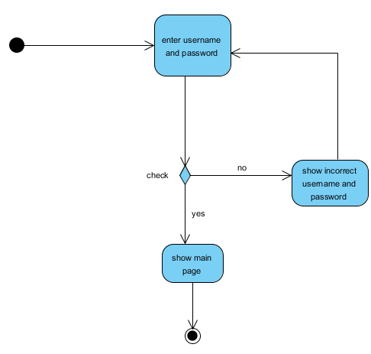

Register
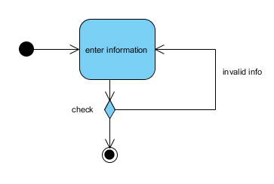

Add lost pet report
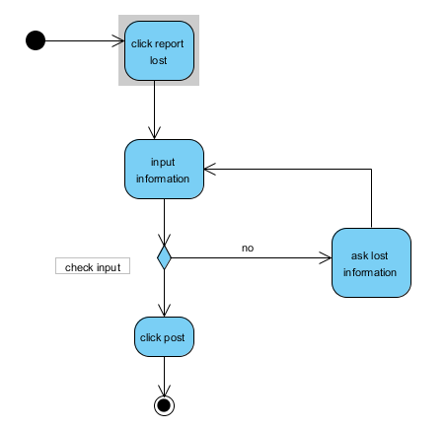

Add find report
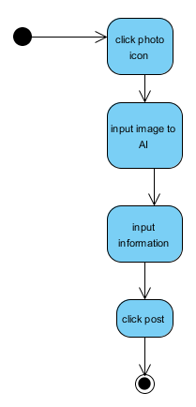

Contact another user

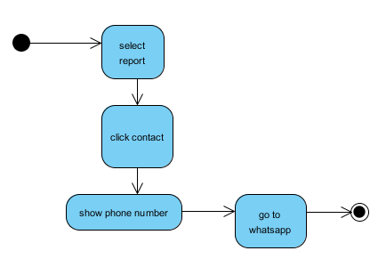

Ai analysis
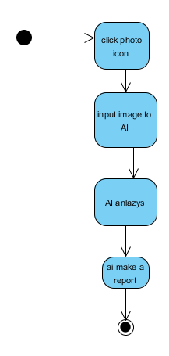

Documentation for detailed design
User Interface Design
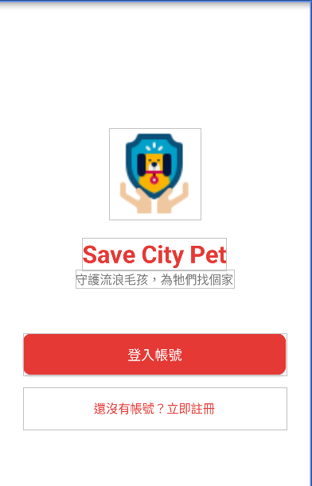
User Interface Description：
This is first page when you use this app
1.click "login" go to login page
2.click "register new account" go to Register page

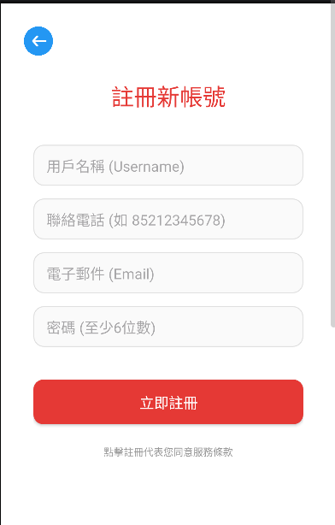
User Interface Description：
This is Register page
1.Enter email and password and click " register " to register a account
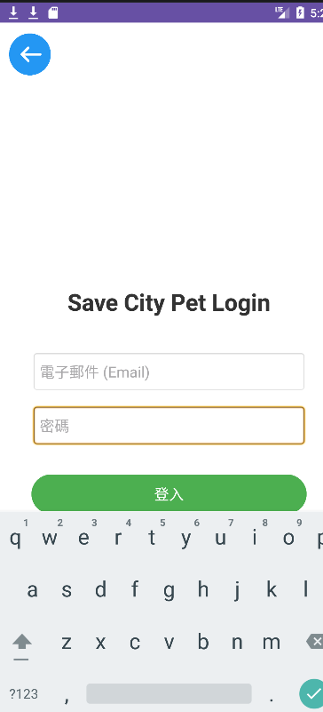
User Interface Description：
This is Login page
1.enter email, password and click "login" to login

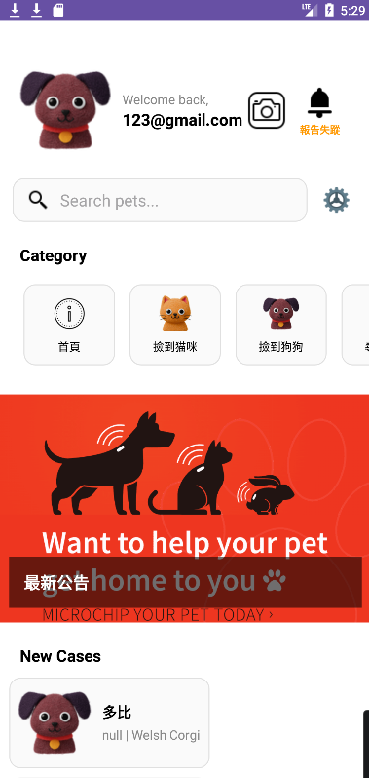
User Interface Description：
This is Main page, if login success you will go to this page
1. show all report from in here, you can click it to report page
2. click the photo page, go to AI analysis page
3.click "report lost" go to Upload lost report page
4.input pet name in search pet can show the report

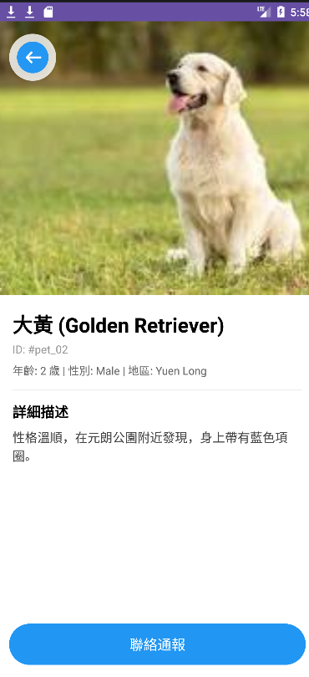
User Interface Description：
This is Find report page, if someone find a pet will make a report here
1.show the finded pet info in here
2.click "contact" can contact the pet finder

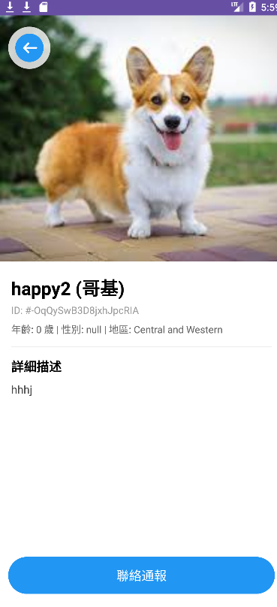
User Interface Description：
This is Lost report page, if someone lost a pet will make a report here
1.show the lost pet info in here
2. click "contact” can contact the pet owner

account page
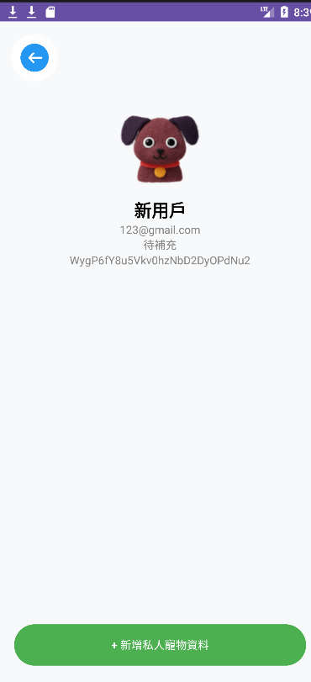
User Interface Description：
This is account page
1.click "add Private pet " to input the Private pet data

Private pet page
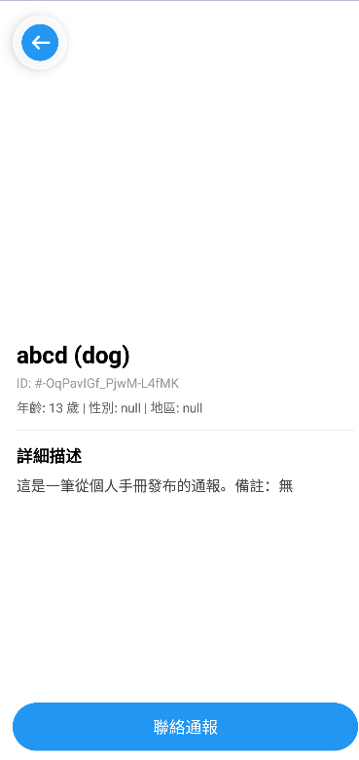
User Interface Description：
This is Private pet page
1.when you add a private you can see the report in here


User Interface Description：
This is Setting page
1.click "logout "can logout ,you will back to first page

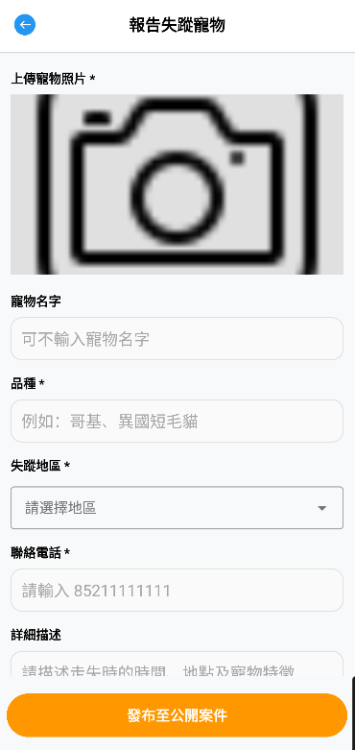
User Interface Description：
This is Upload lost report page, you can make a lost report here
1.you must upload a pet photo and breed
2. you must input a missing area
3. you must input a phone number
4.pet name and describe is not necessary
5.click "post" will create a report, can see it in main page
AI page
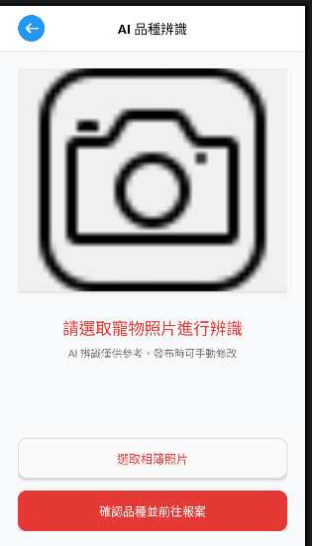
User Interface Description：
This is AI page, you can use AI in this page
1.click "select from photo album" to show the photo to image view
2.click "take photo " to show the photo to image view
3.click "start identification" to use ai analyze the photo

Implementation
Test Case
Test Case #: T001 Test Case Name: register
Design by: kwok chiu chit Executed by: kwok chiu chit
Short Description: register account

Step | Action | Expected System Response | Pass / Fail | Comment
Step Action 1 | Open app | Show first page | Pass
Step Action 2 | Click register | Show register page | pass
Step Action 3 | Enter user data and click register | Show successful message | pass

Test Case #: T002 Test Case Name: login
Design by: kwok chiu chit Executed by: kwok chiu chit
Short Description: Login account
Pre-conditions:The user has a system account。
Step | Action | Expected System Response | Pass / Fail | Comment
Step Action 1 | Open app | Show first page | Pass
Step Action 2 | Click login | Show login page | pass
Step Action 3 | Enter user data and click login | Show main page | pass

Test Case #: T003 Test Case Name: Select lost report
Design by: kwok chiu chit Executed by: kwok chiu chit
Short Description: Select a lost report
Pre-conditions: has a lost report.
Step | Action | Expected System Response | Pass / Fail | Comment
Step Action 1 | Select search cat/dog | List report under main page | Pass
Step Action 2 | Select lost report | Show report | pass

Test Case #: T004 Test Case Name: Get contact
Design by: kwok chiu chit Executed by: kwok chiu chit
Short Description: Get contact form lost report
Pre-conditions: phone number is correct。
Step | Action | Expected System Response | Pass / Fail | Comment
Step Action 1 | Select lost report | Show report | pass
Step Action 2 | Click "contact" | Go to WhatsAPP | pass

Test Case #: T005 Test Case Name: Select find report
Design by: kwok chiu chit Executed by: kwok chiu chit
Short Description: Select a find report
Pre-conditions: has a finding report.
Step | Action | Expected System Response | Pass / Fail | Comment
Step Action 1 | Select find cat/dog | List report under main page | Pass
Step Action 2 | Select find report | Show report | pass
Test Case #: T006 Test Case Name: Get contact
Design by: kwok chiu chit Executed by: kwok chiu chit
Short Description: Get contact form find report
Pre-conditions: phone number is correct。
Step | Action | Expected System Response | Pass / Fail | Comment
Step Action 1 | Select find report | Show report | pass
Step Action 2 | Click "contact" | Go to WhatsAPP | pass

Test Case #: T007 Test Case Name: Show account info
Design by: kwok chiu chit Executed by: kwok chiu chit
Short Description: Show account info
Step | Action | Expected System Response | Pass / Fail | Comment
Step Action 1 | Click the account image in main page | Go to account page | Pass

Test Case #: T008 Test Case Name: add Private pet
Design by: kwok chiu chit Executed by: kwok chiu chit
Short Description: add Private pet info
Step | Action | Expected System Response | Pass / Fail | Comment
Step Action 1 | Click the account image, in main page | Go to account page | Pass
Step Action 2 | Click add private pet data | Go to private pet page | pass
Step Action 3 | add private pet data | Show the input data | pass
Step Action 4 | Click save | Show the report  In main page | pass

Test Case #: T009 Test Case Name: create lost pet report
Design by: kwok chiu chit Executed by: kwok chiu chit
Short Description: add lost pet report
Step | Action | Expected System Response | Pass / Fail | Comment
Step Action 1 | Click the report lost, in main page | Go to Upload lost report page | Pass
Step Action 2 | add lost pet data | Show the input data | pass
Step Action 4 | Click post | Show the report  In main page | pass

Test Case #: T010 Test Case Name:Use ai
Design by: kwok chiu chit Executed by: kwok chiu chit
Short Description: use ai to analyze photo
Step | Action | Expected System Response | Pass / Fail | Comment
Step Action 1 | Click the creamer icon, in main page | Go to AI analyze page | Pass
Step Action 2 | Input a photo | Show the input photo | pass
Step Action 4 | Click start identification | Show the ai identification  report | pass

Test Case #: T011 Test Case Name: logout
Design by: kwok chiu chit Executed by: kwok chiu chit
Short Description: Logout account
Step | Action | Expected System Response | Pass / Fail | Comment
Step Action 1 | Click the setting icon, in main page | Go to AI setting page | Pass
Step Action 2 | Click logout account | Go to first page | pass

Results and conclusions
1.Limitations of the proposed solution
AI Accuracy Constraints
Breed recognition performs poorly on mixed-breed pets, young puppies, or photos with poor lighting/angles。 The system may misclassify or return low-confidence results.
Android-Only Restriction
Initial release excludes iOS users and web user, excluding a significant portion of pet owners.
No Hardware Integration
The system does not support GPS trackers, which could provide real-time location data for lost pets.

2. Conclusions
Because all the members underestimate the difficulty of this project. It has some functions we have removed from this project. We had plans to build a web, it can connect to the android app. But we have canceled it. Also, we had planned to use the GPS to get the pet location automation. We have canceled these functions, and now it needs users to input the location itself.
Although that has many challenges, the system has finally been established and implemented. Though there may be some bugs in the system, the team has succeeded to build up the system with our professional skills and all of their efforts.

Appendices
1. Initial Report Project Schedule
Task  ID | Task Name | Duration | Start Day | End Day | Assigned | Predecessors
1 | Research / Problem Finding | 7 Days | 19/9 | 26/9 | Cheung Man Hei, Xie Tsun Kit
2 | Solution | 4 Days | 26/9 | 30/9 | Cheung Man Hei,  Xie Tsun Kit
3 | Basic Design | 7 Day | 1/10 | 8/10 | Xie Tsun Kit
4 | Proposal | 7 Days | 9/10 | 16/10 | Xie Tsun Kit
5 | Technology research | 6 Days | 17/10 | 23/10 | Xie Tsun Kit
6 | Web Crawler for data | 10 Days | 31/10 | 9/11 | Cheung Man Hei
7 | GUI Design | 7 Days | 9/11 | 16/11 | LEUNG Ka Hei
8 | Develop Mobile App | 76 Days | 8/12/25` | 4/3/26 | All Members
9 | Database setting | 14 Days | 16/10 | 30/10 | KWOK Chiu Chit
10 | AI Training/ Design Output | 14 Days | 16/10 | 30/10 | Cheung Man Hei
11 | Test and Debug | 14 | 5/2 | 25/2 | KWOK Chiu Chit
12 | User Survey | 14 | 5/2 | 25/2 | Chan Yeut Yi  Leung Ka Hei

2.project log book
1 | Research / Problem Finding | 7 Days | 19/9 | 26/9 | Cheung Man Hei, Xie Tsun Kit
2 | Solution | 4 Days | 26/9 | 30/9 | Cheung Man Hei,  Xie Tsun Kit
3 | Basic Design | 7 Day | 1/10 | 8/10 | Xie Tsun Kit
4 | Proposal | 7 Days | 9/10 | 16/10 | Xie Tsun Kit
5 | Technology research | 6 Days | 17/10 | 23/10 | Xie Tsun Kit
6 | Web Crawler for data | 10 Days | 31/10 | 9/11 | Cheung Man Hei
7 | GUI Design | 7 Days | 9/11 | 16/11 | LEUNG Ka Hei
8 | Database Design | 7 Days | 17/11 | 24/11 | Kwok chiu chit
9 | AI Training/ Design Output | 14 Days | 25/11 | 8/12 | Cheung Man Hei
10 | Develop Mobile App | 76 Days | 8/12/25` | 4/3/26 | All Members
11 | Integration all function | 25 Days | 5/3/26 | 30/3/26 | All Members
12 | Test and Debug | 20 Days | 31/3/26 | 15/4/26 | KWOK Chiu Chit  , Cheung Man Hei  , Xie Tsun Kit
13 | Write final report | 3Days | 16/4/26 | 19/4/26 | Kwok chiu chit

Program listing
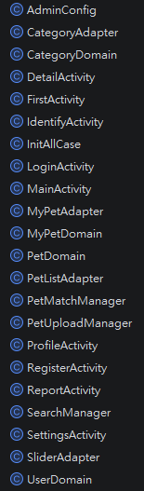
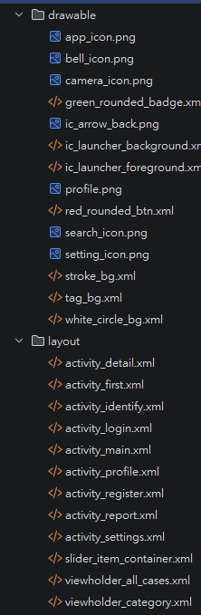
- Core ai analysis
private void runInference() {
if (selectedBitmap == null) return;

try {
// 1. 初始化模型
PetBreedModel model = PetBreedModel.newInstance(this);

Bitmap scaledBitmap = Bitmap.createScaledBitmap(selectedBitmap, 224, 224, true);
org.tensorflow.lite.support.image.ImageProcessor imageProcessor =
new org.tensorflow.lite.support.image.ImageProcessor.Builder()
.add(new org.tensorflow.lite.support.common.ops.NormalizeOp(0.0f, 255.0f))
.build();

TensorImage tensorImage = new TensorImage(DataType.FLOAT32);
tensorImage.load(scaledBitmap);
tensorImage = imageProcessor.process(tensorImage);

PetBreedModel.Outputs outputs = model.process(tensorImage.getTensorBuffer());

float[] confidenceArray = outputs.getOutputFeature0AsTensorBuffer().getFloatArray();
List<String> labels = FileUtil.loadLabels(this, "labels.txt");

int maxIndex = 0;
float maxConfidence = 0;
for (int i = 0; i < confidenceArray.length; i++) {
if (confidenceArray[i] > maxConfidence) {
maxConfidence = confidenceArray[i];
maxIndex = i;
}
}

if (maxIndex < labels.size()) {
String rawBreed = labels.get(maxIndex);
identifiedBreed = breedTranslation.getOrDefault(rawBreed, rawBreed);

if (maxConfidence < 0.4f) {
tvResult.setText("辨識結果：不確定 (可能是 " + identifiedBreed + "?)");
tvResult.setTextColor(android.graphics.Color.GRAY);
} else {
tvResult.setText("辨識結果：" + identifiedBreed +
"\n信心度：" + String.format("%.1f%%", maxConfidence * 100));
tvResult.setTextColor(android.graphics.Color.parseColor("#E53935"));
}
}

model.close();
} catch (Exception e) {
e.printStackTrace();
Toast.makeText(this, "辨識失敗：" + e.getMessage(), Toast.LENGTH_SHORT).show();
}
}
- Matching program
public void findMatch(PetDomain newPet) {
String breed = newPet.getBreed();
String district = newPet.getDistrict();
String gender = newPet.getGender();
String categoryId = newPet.getCategoryId();
// 撿到 (01, 02) -> 找 尋找 (03, 04)
// 尋找 (03, 04) -> 找 撿到 (01, 02)
String targetPrefix = (categoryId.startsWith("01") || categoryId.startsWith("02")) ? "0" : "0";
// 簡單邏輯：如果是 01/02，目標搜 03/04；反之亦然
boolean lookingForMissing = categoryId.contains("found");

databaseReference.addListenerForSingleValueEvent(new ValueEventListener() {
@Override
public void onDataChange(@NonNull DataSnapshot snapshot) {
ArrayList<PetDomain> matchList = new ArrayList<>();

for (DataSnapshot ds : snapshot.getChildren()) {
PetDomain otherPet = ds.getValue(PetDomain.class);
if (otherPet == null || ds.getKey().equals(newPet.getCaseID())) continue;

// 💡 2. 交叉檢查分類
boolean isOpposite = false;
if (lookingForMissing && otherPet.getCategoryId().contains("missing")) isOpposite = true;
if (!lookingForMissing && otherPet.getCategoryId().contains("found")) isOpposite = true;

if (isOpposite) {
// 💡 3. 三重模糊比對 (忽略大小寫與空格)
boolean bMatch = breed != null && otherPet.getBreed() != null &&
breed.trim().equalsIgnoreCase(otherPet.getBreed().trim());

boolean dMatch = district != null && otherPet.getDistrict() != null &&
district.trim().equalsIgnoreCase(otherPet.getDistrict().trim());

// 性別處理「公 (Male)」與「Male」的相容
String g1 = gender.toLowerCase();
String g2 = otherPet.getGender().toLowerCase();
boolean gMatch = g1.contains(g2) || g2.contains(g1);

if (bMatch && dMatch && gMatch) {
otherPet.setCaseID(ds.getKey());
matchList.add(otherPet);
}
}
}

if (!matchList.isEmpty()) {
showMatchResultDialog(matchList);
} else {
Log.d("PetMatch", "沒有找到匹配案件");
}
}

@Override
public void onCancelled(@NonNull DatabaseError error) {}
});
}
- Admin permission
public class DetailActivity extends AppCompatActivity {
@Override
protected void onCreate(Bundle savedInstanceState) {
super.onCreate(savedInstanceState);
setContentView(R.layout.activity_detail);

// 1. 接收傳過來的物件
PetDomain pet = (PetDomain) getIntent().getSerializableExtra("object");

if (pet != null) {
// 2. 綁定元件
TextView tvTitle = findViewById(R.id.detailTitle);
TextView tvDesc = findViewById(R.id.detailDescription);
TextView tvCase = findViewById(R.id.tvCaseID);
ImageView imgPic = findViewById(R.id.detailPic);
TextView tvInfo = findViewById(R.id.tvDetailInfo);
Button btnContact = findViewById(R.id.btnContact);

// 3. 填入基礎資料
String petBreed = pet.getBreed();
if (petBreed != null && !petBreed.isEmpty()) {
tvTitle.setText(pet.getTitle() + " (" + petBreed + ")");
} else {
tvTitle.setText(pet.getTitle());
}

tvDesc.setText(pet.getDescription());
tvCase.setText("ID: #" + pet.getCaseID());
tvInfo.setText("年齡: " + pet.getAge() + " 歲 | 性別: " + pet.getGender() + " | 地區: " + pet.getDistrict());

// 4. 顯示圖片
Glide.with(this).load(pet.getPicUrl()).into(imgPic);

// 💡 5. 權限判斷：Admin_01 vs 普通用戶
if (AdminConfig.isAdmin()) {
// --- 管理員模式 (IVE TM) ---
btnContact.setText("管理員操作 (已歸還 / 刪除)");
btnContact.setBackgroundTintList(ColorStateList.valueOf(Color.RED));

btnContact.setOnClickListener(v -> {
String[] options = {"標記為已歸還 (保存數據)", "強制刪除案件", "取消"};
new AlertDialog.Builder(this)
.setTitle("Admin_01 權限操作")
.setItems(options, (dialog, which) -> {
if (which == 0) {
archiveCase(pet); // 搬移至 FoundHistory
} else if (which == 1) {
deleteCase(pet.getCaseID()); // 直接移除
}
}).show();
});
} else {
// --- 普通用戶模式 (WhatsApp 聯絡) ---
btnContact.setOnClickListener(v -> {
String phoneNumber = pet.getPhone();
if (phoneNumber != null && !phoneNumber.isEmpty()) {
String rawMessage = "你好，我想查詢關於案件 #" + pet.getCaseID() + " (" + pet.getTitle() + ") 的資訊。";
String urlEncodedText = Uri.encode(rawMessage);
String url = "https://wa.me/" + phoneNumber + "?text=" + urlEncodedText;

try {
Intent intent = new Intent(Intent.ACTION_VIEW);
intent.setData(Uri.parse(url));
startActivity(intent);
} catch (Exception e) {
// 備案：簡訊
Intent smsIntent = new Intent(Intent.ACTION_VIEW);
smsIntent.setData(Uri.parse("smsto:" + phoneNumber));
smsIntent.putExtra("sms_body", rawMessage);
startActivity(smsIntent);
}
} else {
Toast.makeText(this, "無法取得聯絡電話", Toast.LENGTH_SHORT).show();
}
});
}
}

// 返回按鈕
findViewById(R.id.btnArrow).setOnClickListener(v -> finish());
}
- Upload logic
private void validateAndSubmit() {
String name = etName.getText().toString().trim();
String breed = etBreed.getText().toString().trim();
String district = etDistrict.getText().toString().trim();
String desc = etDesc.getText().toString().trim();
String ageStr = etAge.getText().toString().trim();

String rawPhone = etPhone.getText().toString().trim();
String selectedCode = spinnerPhoneCode.getSelectedItem().toString();
String fullPhone = selectedCode + rawPhone;

int selectedCatIndex = spinnerCategory.getSelectedItemPosition();
String categoryId = catIds[selectedCatIndex];

int selectedGenderId = rgGender.getCheckedRadioButtonId();
if (selectedGenderId == -1) {
Toast.makeText(this, "請選擇性別", Toast.LENGTH_SHORT).show();
return;
}
RadioButton rbSelected = findViewById(selectedGenderId);
String gender = rbSelected.getText().toString();

// 必填檢查
if (selectedImageUri == null) {
Toast.makeText(this, "請上傳照片", Toast.LENGTH_SHORT).show();
return;
}
if (breed.isEmpty() || district.isEmpty() || rawPhone.isEmpty() || ageStr.isEmpty()) {
Toast.makeText(this, "請填寫品種、地區、年齡及電話", Toast.LENGTH_SHORT).show();
return;
}

int age = Integer.parseInt(ageStr);

DatabaseReference itemsRef = FirebaseDatabase.getInstance().getReference("Items");
String newCaseKey = itemsRef.push().getKey();

final String finalName = name.isEmpty() ?
"Case #" + (newCaseKey != null ? newCaseKey.substring(newCaseKey.length() - 5) : "Unknown") : name;

btnSubmit.setEnabled(false);
Toast.makeText(this, "正在發布案件...", Toast.LENGTH_SHORT).show();

MediaManager.get().upload(selectedImageUri)
.unsigned("save_city_pet_presetName") // 💡 確保此 Preset Name 正確
.callback(new UploadCallback() {
@Override
public void onStart(String requestId) {
}

@Override
public void onProgress(String requestId, long bytes, long totalBytes) {
}

@Override
public void onSuccess(String requestId, Map resultData) {
String imageUrl = (String) resultData.get("secure_url");
// 呼叫上傳，注意參數順序需與定義一致
uploadToPublicItems(newCaseKey, finalName, breed, district, fullPhone, desc, imageUrl, gender, categoryId, age);
}

@Override
public void onError(String requestId, ErrorInfo error) {
btnSubmit.setEnabled(true);
Toast.makeText(ReportActivity.this, "圖片上傳失敗: " + error.getDescription(), Toast.LENGTH_SHORT).show();
}

@Override
public void onReschedule(String requestId, ErrorInfo error) {
}
}).dispatch();
}
Json
{
"Category": {
"00_home": {
"title": "首頁",
"picUrl": "https://res.cloudinary.com/dmjxt60yw/image/upload/q_auto/f_auto/v1776258849/info_icon_bweb5j.png"
},
"01_found_cat": { "title": "撿到猫咪", "picUrl": "https://res.cloudinary.com/dmjxt60yw/image/upload/q_auto/f_auto/v1776246094/cat_icon_qgja6m.png" },
"02_found_dog": { "title": "撿到狗狗", "picUrl": "https://res.cloudinary.com/dmjxt60yw/image/upload/q_auto/f_auto/v1776246227/dog_icon_iebyau.png" },
"03_missing_cat": { "title": "尋找猫咪", "picUrl": "https://res.cloudinary.com/dmjxt60yw/image/upload/q_auto/f_auto/v1776246094/cat_icon_qgja6m.png" },
"04_missing_dog": { "title": "尋找狗狗", "picUrl": "https://res.cloudinary.com/dmjxt60yw/image/upload/q_auto/f_auto/v1776246227/dog_icon_iebyau.png" }
},
"Banner": [
{ "url": "https://res.cloudinary.com/dmjxt60yw/image/upload/q_auto/f_auto/v1776256229/poster1_rkg20r.png" },
{ "url": "https://res.cloudinary.com/dmjxt60yw/image/upload/q_auto/f_auto/v1776256237/poster2_dhzrze.png" }
],
"Items": {
"pet_01": {
"title": "小花",
"caseID": "case_01",
"phone": "85259246707",
"categoryId": "03_missing_cat",
"picUrl": "https://res.cloudinary.com/dmjxt60yw/image/upload/q_auto/f_auto/v1776256332/lost_cat_1_eyfotx.jpg",
"age": 3,
"district": "Tuen Mun",
"gender": "Male",
"breed": "阿比西尼亞貓",
"description": "於屯門走失"
},"pet_02": {
"title": "大黃",
"phone": "85222222222",
"caseID": "case_02",
"categoryId": "02_found_dog",
"picUrl": "https://res.cloudinary.com/dmjxt60yw/image/upload/q_auto/f_auto/v1776263954/lost_dog_1_zojnay.jpg",
"age": 2,
"district": "Yuen Long",
"gender": "Male",
"breed": "金毛尋回犬",
"description": "性格溫順，在元朗公園附近發現，身上帶有藍色項圈。"
},
"pet_03": {
"title": "Snowball",
"phone": "85233333333",
"caseID": "case_03",
"categoryId": "02_found_dog",
"picUrl": "https://res.cloudinary.com/dmjxt60yw/image/upload/q_auto/f_auto/v1776264079/found_dog_1_ak4rsi.jpg",
"age": 1,
"district": "Shatin",
"gender": "Female",
"breed": "Samoyed",
"description": "在沙田運動場附近發現，非常親人，暫時由我照顧。"
}
},
"Users": {
"xzMyJ7jNlRV31Qurk46tCAISfiW2": {
"username": "MeMes Lee",
"phone": "85211111111",
"myPets": {
"mypet_01": {
"name": "多比",
"breed": "Welsh Corgi",
"age": 2,
"gender": "Female",
"district": "Shatin",
"picUrl": "/data/user/0/com.example.save_city_pet/files/my_pets/pet_1776286315067.jpg",
"notes": "這是我的私人寵物，別人看不到"
}
}
},
"kjofM1zN8QfW1wuDUHSxCGbWWg33": {
"username": "IVE (TM)",
"phone": "85259246707"
}
}
}

installation guide
Open android
copy this berfore run
Open local.properties:
sdk.dir=C\:\\Users\\user\\AppData\\Local\\Android\\Sdk
CLOUDINARY_CLOUD_NAME="Root"
CLOUDINARY_API_KEY="623729695394899"
CLOUDINARY_API_SECRET="7ikRwLJDkocOhaoWUMlB5Km5NgA"

Open gradle.properties:
org.gradle.jvmargs=-Xmx2048m -Dfile.encoding=UTF-8
android.useAndroidX=true
android.enableJetifier=true

Open build.gradle.kts:
plugins {
id("com.android.application") version "8.9.1" apply false
id("com.android.library") version "8.9.1" apply false
id("com.google.gms.google-services") version "4.4.2" apply false
}

